Concise Report from Centre for Ethics for UGC 18/2/2014
(detailed report available on the website www.ethics.edu.in)

Having perceived the need for closing the gap between technological health advancements and medical ethics, Yenepoya University, in a bold, academic leadership initiative, established the Centre for Ethics, in February 2011.

Mission: To inculcate in all professionals a sense of ethical responsibility towards their job, family and society thereby making them better citizens, in a global and professional sense.

The Centre for Ethics runs following innovative academic programs with innovations in curricular transactions and evaluation, which encourages lifelong learning:
- Postgraduate Diploma in Bioethics & Medical Ethics (since 2011): One year course, January to December, Intake 25/year, so far 25 students have passed. 2014 batch 14 enrolled
- Post Graduate Diploma In Clinical Ethics (since 2013): One year course, Intake 25/year, so far 8 students enrolled.
- Intensive short training course on Ethical issues in Biomedical research (since 2012): Five-day interactive workshop meant for training of ethics committee members and potential researchers in research ethics. Conducted under sponsorship from ICMR and with International Faculty. So far 78 faculties have been trained.
- Choice based credit course (electives) in Biomedical Ethics and Environmental Ethics for Health care Graduates (Since 2014): 30 students enrolled.
- Applied Ethics for Bachelor in Physiotherapy (BPT) Interns (since 2014): Six two-hour sessions during internship focusing on professional ethics.-9 students
- Bioethics teaching for Bachelor (BPT) & Masters in Physiotherapy (MPT): Engages students as per University approved physiotherapy curriculum (20 hours)-3 students

Collaborations: Centre for Ethics is in active collaboration with
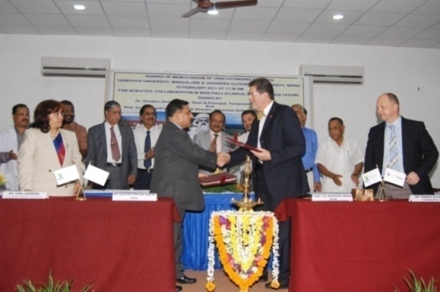
- Johannes Gutenberg University (since 2011):
Centre for Ethics, Yenepoya University & Department of History, Philosophy and Ethics of Medicine, Johannes Gutenberg University, Mainz, Germany. So far 9 students and 2 faculties from JGU have visited us and 2 faculty and 2 post graduates have visited JGU from Yenepoya University. Certificate Course in Clinical Ethics Consultation (CCCEC) was also started in this collaboration which later became PG Diploma in Clinical Ethics.

- Department of Health Care Ethics, Duquesne University, Pittsburgh, USA (since 2012): Dr.Henk ten Have, Former Director of Bioethics division of UNESCO is the Professor and Head of the Centre for Health Care Ethics. In this collaboration Drs. Vina & Ravi Vaswani have co-authored a chapter in a book, where Prof. Henk ten Have is the Chief Editor: Bioethics Education in a Global Perspective. (Springerlink)

International CMEs and Workshops organized, Impact assessment
SL. No | Title | Date | Impact
1 | First Indo German CME in Clinical Ethics | 15 Feb 2011 | Needs assessment for clinical ethics carried out and showed need for course on clinical ethics
2 | Second Indo German CME on Interprofessional Education in Clinical Ethics | 18 Feb 2012 | Increased awareness on multi-disciplinary approach to clinical care in an ethical manner
3 | CME on Research Integrity and Publication Ethics | 28 May 2013 | Junior researchers and doctoral students learned about ethical issues in publication
4 | International CME on Public Health Ethics in India – Issues and Challenges | 12 Sep 2013 | Needs assessment carried out to show that there is scope for starting a course on Public Health Ethics

INTERNATIONAL AND NATIONAL FACULTY VISIT TO CENTRE FOR ETHICS AND DELIVERED GUEST LECTURES TO THE UNIVERSITY:
Dr. Richard Cash : Senior Lecturer on Global Health, Department of Global Health and Population, Harvard School of Public Health, Harvard University USA and Visiting Professor at the Public Health Foundation of India, Delhi, from 27th to 31st May and 1st June 2012 and 2013.
Dr. Ricardo Chavez: Coordinator - Regional Chapters, Erasmus Mundus Association, Germany, on 8 Nov 2012.
Dr. Alastair Campbell: Chen Su Lan Centennial Professor of Medical Ethics & Director, Centre For Biomedical Ethics, Yong Loo Lin School Of Medicine, National University of Singapore -30th November 2012.
Dr. Russel D’Douza: Chair Of Asia Pacific Bioethics Network Of UNESCO, North West Mental Health Melbourne, Australia on 11th May 2013.
Ms. Claudia Buir: Johannes Gutenberg University Mainz, Germany from 23th April to 7th May 2013.
Dr. Corinna Porteri : Researcher in Bioethics at the IRCCS Saint John of Cod Fatebenefiatelli, Italy, from 14th May to 7th June 2013.
Dr. Angus Dawson: Professor of Public Health Ethics and currently working as Head, Department of Medicine, Ethics, Society and History at the University of Birmingham, U.K. on 12th and 13th September 2013.
Dr.Salma Siddidque; Co-director, Clinical Research, Edinburg Napier Univ, Scotland 9th Feb to 15 Feb 20014.
Prof. Bert Gordijn, Professor and Director, Institute of Ethics Dublin City Univ, Ireland. 12-15 Feb 2014
National
Dr. Anant Bhan: Public Health Ethics Consultant, Pune, 6 Jan, 2014
Dr.Sudhakar Bangera from Clinical Development Service Agency (CDSA), New Delhi 6 Jan 2014
Dr.Suchetha Banerjee: Director training, Clinical Development Services Agency New Delhi 6 Jan2014
Dr. Lavina Noronha: Director, Ave Maria Palliative Care Centre, Vamanjur, Mangalore on 23rd August 2013.
Neha Madhiwalla: Coordinator, Centre for Studies in Ethics and Research Mumbai, from 27th to 31st May and 1st June 2012.
Dr. Nandini K Kumar: Former Deputy General Sr. Grade, (ICMR) on 26th September 2012, May 27-31 2013.
Dr. Seetharam M.R: President, Sri Vivekananda Youth Movement, Saragur, Mysore on 26th December 2012, December 11, 2013
Dr.Chethan Singhai:

Research output 2011 onwards:

National Conferences attended |  | International Conferences  attended |  | Conversion of Conference papers to research publication
Faculty | Student | Faculty | Student | 5
2 | 7 | 10 | 3

Research Output: Publication

Research Projects Completed | International Publications | National Publications | Book Chapter Global bioethics
25 | 7 | 5 | 1

-----------

